**PROGRAMMING EXERCISE**

2.1)

#include<iostream> using namespace std; int main()

{

cout<<" Maths=90\n Physics=99\nChemistry=69"; return 1;

}

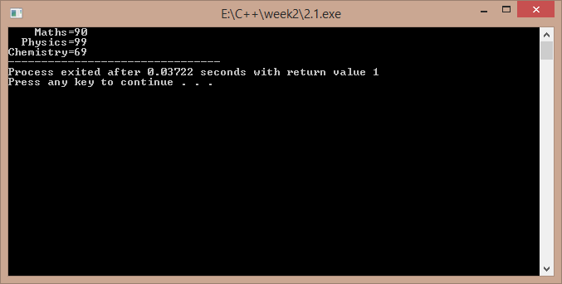

2.2)

#include<iostream> using namespace std; int main()

{

int a,b;

cout<<"enter two numbers : "; cin>>a>>b;

if(a>b)

cout<<"\nthe larger is "<<a; else

cout<<"\n the larger is "<<b; return 1;

}

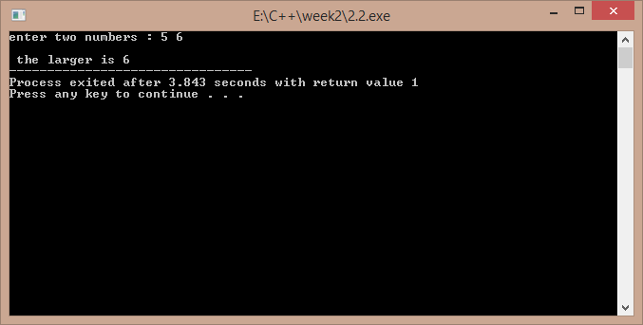

2.3)

#include<iostream> using namespace std; int main()

{

char ch;

cout<<"enter a character : "; cin>>ch;

cout<<"ASCII VALUE IS : "<<(int)ch;

return 1;

}

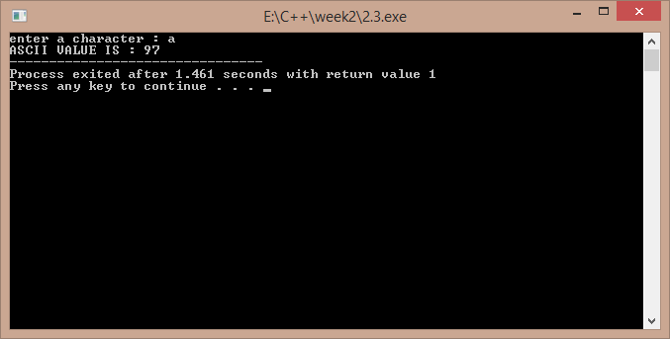

2.4)

#include<iostream> using namespace std; int main()

{

cout<<"enter a,b,c : "; int a,b,c,x; cin>>a>>b>>c;

x=a/b-c;

cout<<"\n the value of x is : "<<x; return 1;

}

a)

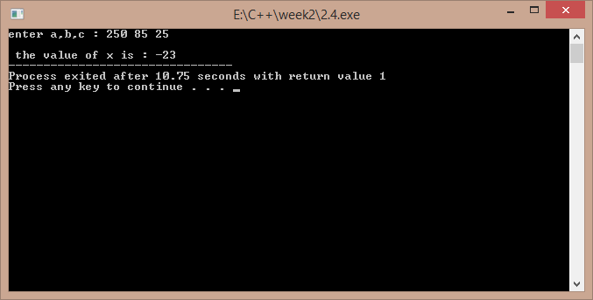

b)

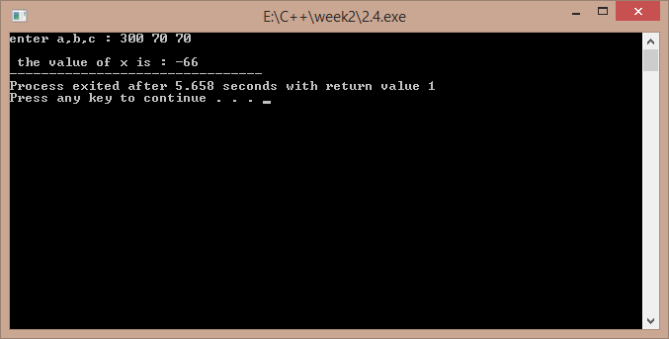

2.5)

#include<iostream>

using namespace std; int main()

{

float c,f;

cout<<"enter the temp in fahrenheit : "; cin>>f;

c=(5/9)*(f-32);

cout<<"temp in celsius is : "<<c; return 1;

}

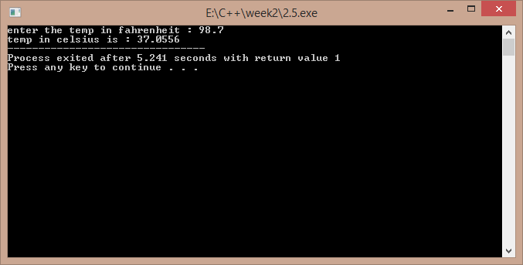

2.6)

#include<iostream> using namespace std; class temp

{

float f,c;

public:

void get(); void cel();

};

void temp::get()

{

cout<<"enter temp in fahrenheit : "; cin>>f;

}

void temp::cel()

{

c=5*(f-32)/9;

cout<<"temp in celcius is : "<<c;

}

int main()

{

temp t; t.get();

t.cel(); return 1;

}

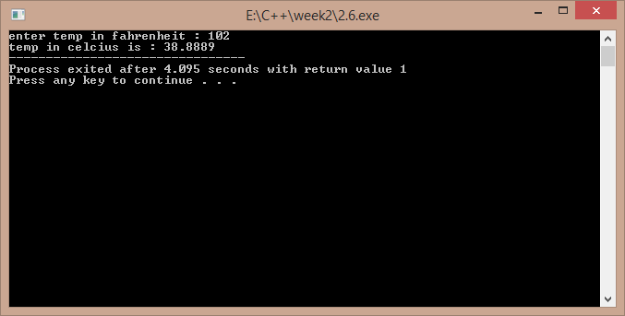

# Programming Questions

1) #include<iostream> using namespace std; int main()

{

cout<<"enter the order of matrices : "; int m,n,i,j;

cin>>m>>n;

int p[10][10],q[10][10],r[10][10];

if(m>10||n>10) //an exception if the array size is huge

{

cout<<"size overload..."; return -1;

}

cout<<"\nenter the elements of the first matrix : "; for(i=0;i<m;i++)

for(j=0;j<n;j++) cin>>p[i][j];

cout<<"\nenter the elements of the second matrix : "; for(i=0;i<m;i++) //input of matrices for(j=0;j<n;j++)

cin>>q[i][j]; for(i=0;i<m;i++)

for(j=0;j<n;j++) //addition

r[i][j]=p[i][j]+q[i][j];

cout<<"\nthe addition matrix is : "; for(i=0;i<m;i++)

{

cout<<endl; for(j=0;j<n;j++)

cout<<r[i][j]<<" "; //display of the result matrix

}

return 1;

}

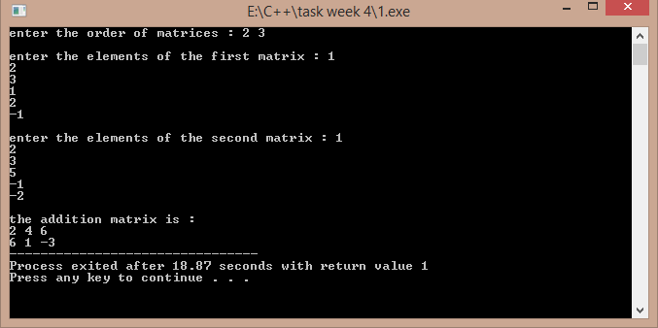

## 2)

#include<iostream> using namespace std;

void multi(int p[10][10],int q[10][10],int r[10][10],int m,int n,int q1)

{

int i,j,k; for(i=0;i<m;i++)

{

//a function to find out the product of matrices

for(j=0;j<q1;j++)

{

r[i][j]=0; for(k=0;k<n;k++) r[i][j]+=p[i][k]*q[k][j];

}

}

}

int main()

{

int p[10][10],q[10][10],r[10][10];int m,n,p1,q1,i,j; cout<<"enter the order of first and second matrix : "; cin>>m>>n>>p1>>q1; if(p1>10||q1>10||m>10||n>10)

{

cout<<"size exceeded ..."; return -1;

}

if(n!=p1)

{

//an exception if there is a wrong input of order

cout<<"wrong order input ..."; return -1;

}

cout<<"enter the elements of first matrix : \n"; for(i=0;i<m;i++)

{

for(j=0;j<n;j++) //input of matrix cin>>p[i][j];

}

cout<<"enter the elements of the second matrix : \n"; for(i=0;i<p1;i++)

{

for(j=0;j<q1;j++) cin>>q[i][j];

}

multi(p,q,r,m,n,q1);

cout<<"the output matrix is : \n"; for(i=0;i<m;i++)

{

cout<<endl; //output of the multiplication matrix for(j=0;j<q1;j++)

cout<<r[i][j]<<" ";

}

return 1;

}

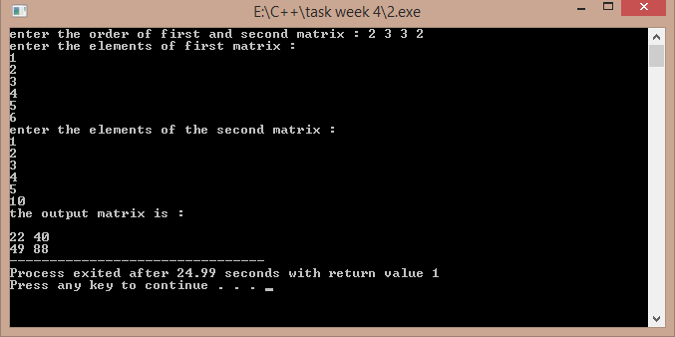

## 3)

#include<iostream> using namespace std;

void call_by_value(int a,int b)

{

int t; t=a; a=b; b=t;

}

void call_by_address(int *a,int *b)

{

int t; t=*a;

*a=*b;

*b=t;

}

void call_by_reference(int &x,int &y)

{

int t;

t=x; x=y; y=t;

}

int &return_by_reference(int a,int b)

{

if(a>b) return a; else return b;

}

int main()

{

cout<<"enter two numbers : "; int a,b,c;

cin>>a>>b;

cout<<"swap by call by value : \n"; //function calls to represent each mechanism call_by_value(a,b);

cout<<a<<" "<<b<<endl; cout<<"swap by call by address : \n"; call_by_address(&a,&b);

cout<<a<<" "<<b<<endl; cout<<"swap by call by refernce : \n"; call_by_reference(a,b);

cout<<a<<" "<<b<<endl;

return_by_reference(a,b)=-4; //the larger value is assigned the value of -4 if(a==-4) //by return by reference mechanism cout<<"first number is larger ..";

else

cout<<"second number is larger .."; return 1;

}

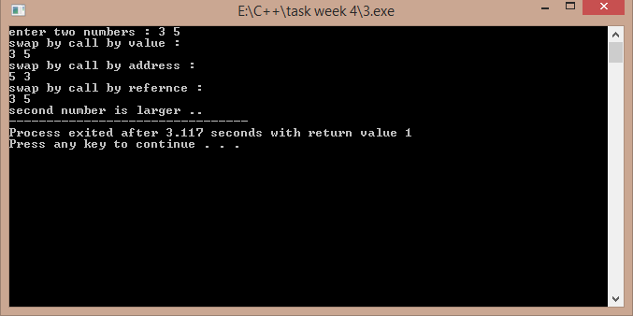

## 4)

#include<iostream> using namespace std; int main()

{

void area(float r,float pi=3.141592); //default value of pi is taken float a,pi; //if the pi value is not passed cout<<"enter the radius of the circle : ";

cin>>a;

cout<<"area by taking default value of pi : "; area(a);

cout<<"\nenter the value of pi : "; cin>>pi;

cout<<"area by taking your value of pi : "; area(a,pi);

return 1;

}

void area(float r,float pi)

{

cout<<(pi*r*r);

}

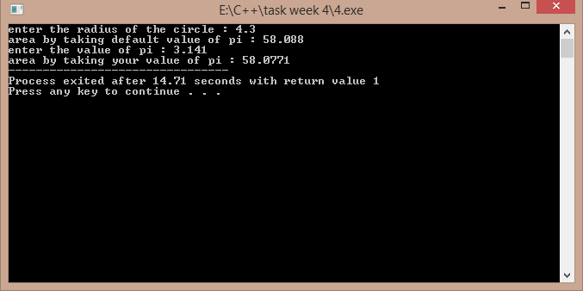

## 5)

#include<iostream>

#include<cmath> using namespace std; float area(float r)

{

return ((3.141592)*r*r);

}

int area(int s)

{

return s*s;

}

int area(int a,int b)

{

return a*b;

}

float area(float a,float b,float c)

{

float s,ar; s=(a+b+c)/2;

ar=sqrt(s*(s-a)*(s-b)*(s-c));

return ar;

}

int main()

{

int a,b,ar;float r,a1,b1,c1,ar1; cout<<"enter the sides of rectangle : "; cin>>a>>b;

ar=area(a,b);

cout<<"\nthe area of rectangle is : "<<ar<<endl; //calling different functions cout<<"enter the sides of the triangle : "; //with the same name cin>>a1>>b1>>c1;

ar1=area(a1,b1,c1);

cout<<"\nthe area of rectangle is : "<<ar1<<endl; cout<<"enter the radius of the circle : ";

cin>>r; ar1=area(r);

cout<<"the area of the circle is : "<<ar1<<endl; cout<<"enter the side of the square : ";

cin>>a; ar=area(a);

cout<<"\nthe area of the square is "<<ar; return 1;

}

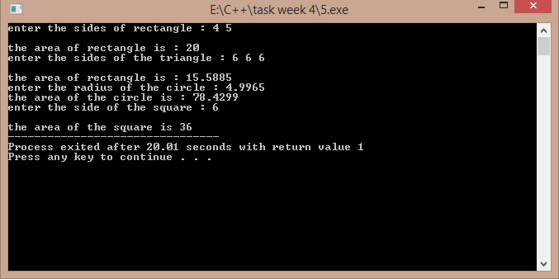

## 6)

#include<iostream> using namespace std;

template<class m> //template named m is used

void firsttwo(m *p,m &n) //a template pointer and the same data type reference is used

{

int i,m1=-1,m2=-1; for(i=0;i<n;i++)

{

if(m1<p[i])

{

m1=p[i];

}

}

for(i=0;i<n;i++)

{

if(m2<p[i]&&p[i]!=m1) //if the found number is not equal to

{ //the largest number .

m2=p[i];

}

}

cout<<"\nlargest and second largest numbers are : "<<m1<<" "<<m2;

}

int main()

{

int n,i;

cout<<"enter the size of the array : "; cin>>n;

int *p=new int[n];

cout<<"enter the elements : \n"; for(i=0;i<n;i++)

{

cin>>p[i]; //calling the template function

}

firsttwo(p,n); return 1;

}

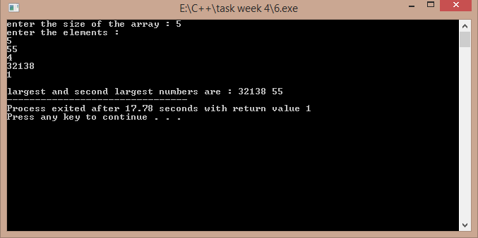

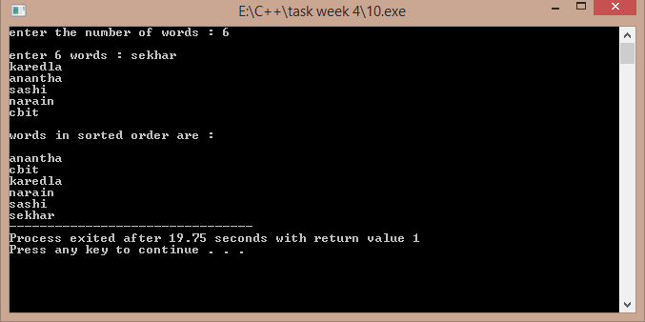

**3.1)**

ALGORITHM:-1)read two numbers

2)call the function swap 3)print the values after swap Function:-

void swap(int &x,int &y)

{

int t=x; x=y; y=t;

}

Return type is void.

Takes two parameters as reference variables.

/*Function program to swap the values of a pair of integers using reference variables. Developed by Sekhar Karedla of BE ¼ CSE-2, CBIT */

#include<iostream> using namespace std;

void swap(int &x,int &y) //function defination

{

int t=x;

x=y;

y=t;

}

int main()

{

cout<<"enter two numbers : "; //reading numbers

int a,b;

cin>>a>>b;

swap(a,b);

cout<<"after swapping : "<<a<<" "<<b; //displaying numbers

return 1;

}

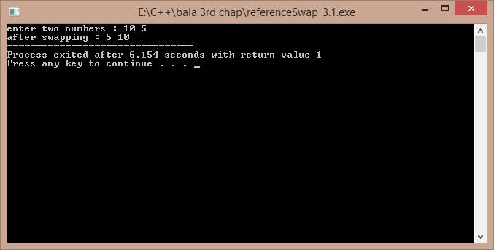

**3.2)**

ALGORITHM:-

1)read the size of vector from the user 2)create the vector using new operator

3)display the default values so as to show the created vector

/*A program to create a vector of size as demanded by the user , Developed by Sekhar Karedla BE ¼ CSE-2,CBIT*/

#include<iostream> using namespace std; int main()

{

int m,i;

cout<<"enter the size of vector : ";

cin>>m; //reading size

int *p=new int[m]; //creating the vector

cout<<"the garbage values are : \n";

for(i=0;i<m;i++) //displaying the garbage values

{

cout<<p[i]<<"\n";

}

return 1;

}

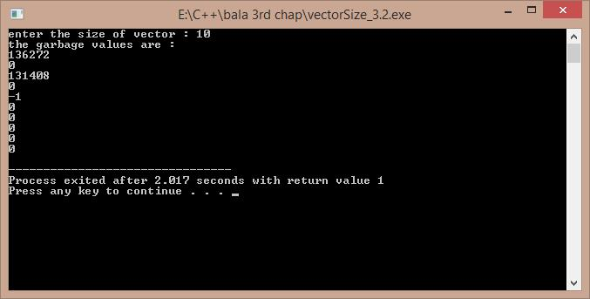

**3.3)**

ALGORITHM:-1)start

2)read the number of lines from user 3)use two for loops to get the pattern 4)end

/*A program to display the following pattern 1 22 333 4444

55555

……

, Developed by Sekhar Karedla BE ¼ CSE-2,CBIT*/ #include<iostream>

using namespace std; int main()

{

int i,j,m;

cout<<"enter the no of lines : "; cin>>m;

for(i=1;i<=m;i++)

{

for(j=1;j<=i;j++)

{

cout<<i;

}

cout<<"\n";

}

return 1;

}

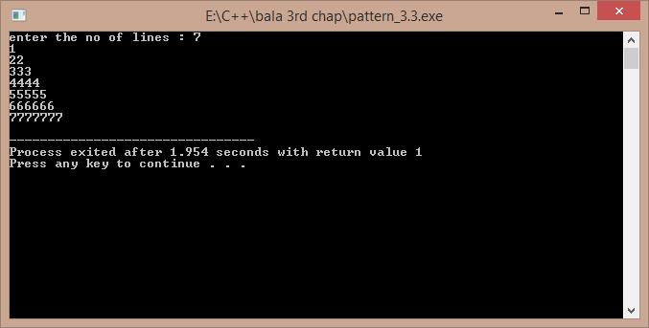

**3.5)**

ALGORITHM:-1)start

2)read the number of ballots from the user 3)create an array on the ballots , using new operator 4)enter the result of each ballot using a for loop

5)calculate the result and spoilt ballots using again a for loop 6)display the results

7)end

/* A program to calculate the results of an election , . Developed by Sekhar Karedla BE ¼ CSE-2,CBIT*/

#include<iostream> using namespace std; int main()

{

cout<<"enter the no of ballots : "; //reading the number of ballots

static int n,i,r[6]; //static declaration so as get the results array to 0

cin>>n;

int *p=new int[n];

cout<<"enter the results of ballot : \n";

for(i=0;i<n;i++)

{

cin>>p[i];

if(p[i]>0&&p[i]<6) //reading the results of ballots as well as calculating the results

{

r[p[i]-1]++;

}

else

r[5]++;

}

for(i=0;i<5;i++)

{

cout<<"\n the no of votes for "<<i+1<<" party is "<<r[i];

}

cout<<"\n the spoiled ballots are "<<r[5];

return 1;

}

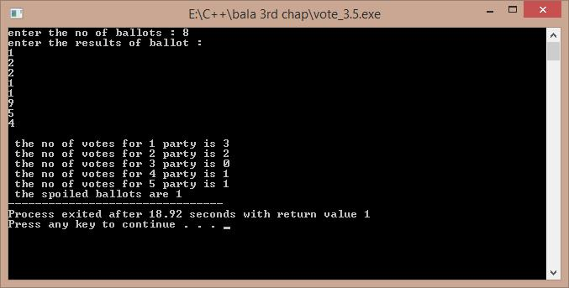

**3.6)**

ALGORITHM:-1)start

2)create a class which contains the data related to a player and functions

3)create a pointer in the main function to create a array of objects using new operator 4)input the values for each object and print them in a tabular form with the batting average 5)end

/*A program to tabulate the details of the cricket player with the batting average. Developed by Sekhar Karedla BE ¼ CSE-2,CBIT*/

#include<iostream> using namespace std; class player

{

char name[100]; int runs;

int inn; int t;

float avg;

public:

void getdata(); void display();

};

void player::getdata()

{

cout<<"enter name : "; cin>>name;

cout<<"enter runs , innings , times not out : "; cin>>runs>>inn>>t;

}

void player::display()

{

avg=float(1.0*runs/(inn-t)); cout<<name<<"\t\t"<<runs<<"\t"<<inn<<"\t"<<t<<"\t\t"<<avg<<"\n";

}

int main()

{

int n,i;

cout<<"\nenter the number of players : "; cin>>n;

player *p=new player[n];

cout<<"enter the details of "<<n<<" players : \n"; for(i=0;i<n;i++)

{

p[i].getdata();

}

cout<<"PLAYER NAME\t"<<"RUNS\t"<<"INNINGS\t"<<"TIMES NOT OUT\t"<<"AVERAGE\n"; for(i=0;i<n;i++)

{

p[i].display();

}

return 1;

}

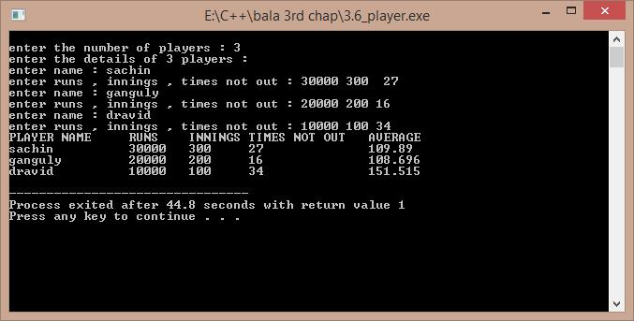

**3.7)a)**

ALGORITHM:-1)start

2)calculate the original value of sinx using cmath header file 3)calculate the sinx value obtained by eulers expansion 4)find the error and compare

5)end

/*A program to compare the original and obtained value of sinx , Developed by Sekhar Karedla CSE-2 BE ¼ ,CBIT*/

#include<iostream>

#include<math.h> using namespace std; int main()

{

long double s,t,x,i,j,n;

cout<<"enter x in degrees : "; //reading the degress cin>>x;

x=x*(3.141/180);

for(j=3;j<1000;j++)

{s=0;t=x;

for(i=2;i<=j;i++)

{

s=s+t;

t=t*-1*x*x/(2*(i-1)*(2*i-1)); //calculating sinx from euler formula

}

if(((s-sin(x))>-0.00000001)&&(s-sin(x))<0.00000001)

{

cout.precision(10);

cout<<"\nthe original value of sinx is : "<<sin(x); cout<<"\nthe obtained value of sinx is : "<<s; cout<<"\nthe order is : "<<j;

break;

}

}

return 1;

}

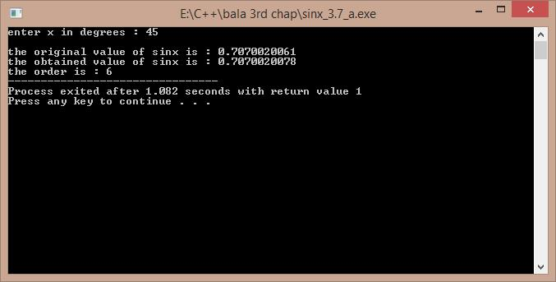

**3.7)b)**

ALGORITHM:-

1)reading the value of x from the user 2)calculating the sum using for loops 3)displaying the result

/*A program to calculate the sum of particular sequence , Developed by Sekhar Karedla CSE-2 BE ¼ ,CBIT*/

#include<iostream> using namespace std; int main()

{

float s,k,p,i,j,n,t;t=1; cout<<"enter N : "; cin>>n;p=1; for(i=1;i<=n;i++) {s=s+p;t=1;

for(j=0;j<i;j++)

{

t=t*(1/(i+1));

}

p=t;

}

cout.precision(10); cout<<"the sum is : "<<s;

return 1;

}

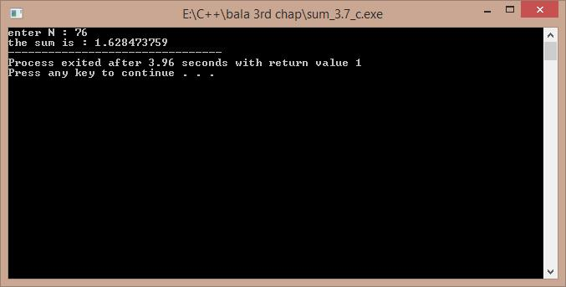

**3.7)c)**

ALGORITHM:-1)start

2)calculate the original value of cosx using cmath header file 3)calculate the cosx value obtained by eulers expansion 4)find the error and compare

5)end

/*A program to compare the original and obtained value of cosx , Developed by Sekhar Karedla CSE-2 BE ¼ ,CBIT*/

#include<iostream>

#include<math.h> using namespace std; int main()

{

float x,t,s,i,j;

cout<<"enter x in degrees : "; cin>>x;

x=x*(3.141/180);

for(j=0;j<1000;j++)

{

s=1;t=-(x*x)/2; for(i=0;i<=j;i=i+2)

{

s=s+t; t=t*-1*x*x/((i+3)*(i+4));

}

if(((s-cos(x))>-0.000001)&&((s-cos(x)<0.000001)))

{

cout.precision(10);

cout<<"\n the original value : "<<cos(x); cout<<"\n the obtained value : "<<s; cout<<"\n order : "<<j;

break;

}

}

return 1;

}

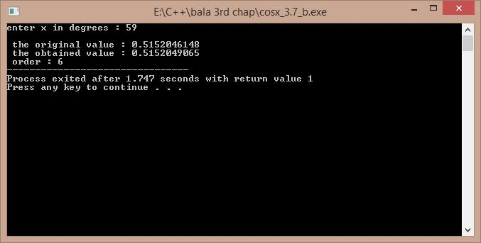

# Program 1

//a program to depict the function overloading concept

#include<iostream> using namespace std; float area(float r)

{

return (3.141)*r*r;

}

int area(int a,int b)

{

return a*b;

}

int area(int s)

{

return s*s;

}

int main()

{

float r,ac;

int a,b,s,ar,as;

cout<<"\nenter the radius of circle : ";

cin>>r; ac=area(r);

cout<<"\nenter the length and breadth of rectangle : "; cin>>a>>b;

ar=area(a,b);

cout<<"\nenter the side of the square : "; cin>>s;

as=area(s);

cout<<"\narea of the circle is : "<<ac; cout<<"\narea of the rectangle is : "<<ar; cout<<"\narea of the sqaure is : "<<as;

return 0;

}

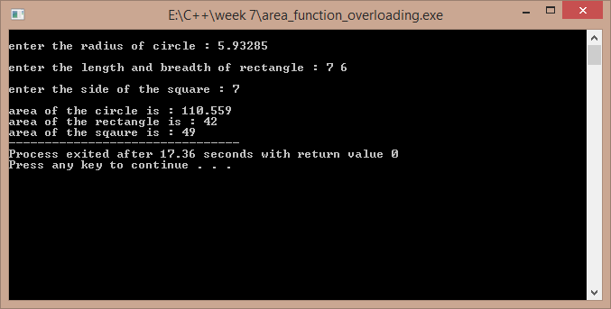

# Program 2

//a program to add complex numbers using operator overloading

#include<iostream> using namespace std; class complex1

{

float real,imag; public:

complex1()

{

real=imag=0;

}

complex1(float a,float b)

{

real=a; imag=b;

}

void display();

complex1 operator +(complex1 m);

};

void complex1::display()

{

cout<<"\n"<<real<<" + "<<imag<<"i"<<endl;

}

complex1 complex1::operator +(complex1 m)

{

complex1 temp; temp.real=this->real+m.real;

temp.imag=this->imag+m.imag; return temp;

}

int main()

{

complex1 a,b; float p,q,r,s;

cout<<"\nenter the real and imaginery part of first complex number : "; cin>>p>>q;

cout<<"\nenter the real and imaginery part of second complex number : ";

Output:-

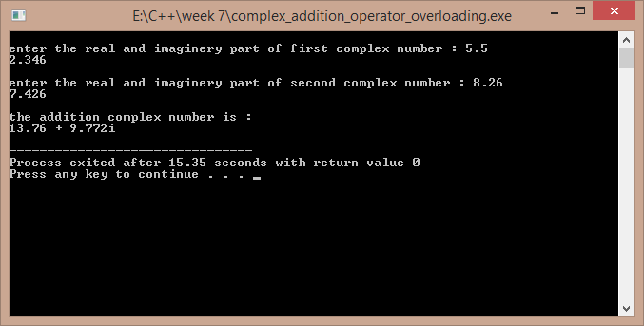

# Program 3

//a program to overload the operator regarding the strings

#include<iostream>

#include<cstring> using namespace std; class str

{

char *s; int l; public:

str()

{

l=0;

s=new char[l+1];

}

str(char *p)

{

l=strlen(p); s=new char[l+1]; strcpy(s,p);

}

str(int k)

{

l=k;

s=new char[l+1];

}

str operator +(str);

int operator <(str); int operator >(str); void operator =(str); int operator !=(str); void display()

{

// cout<<this->l; cout<<"\n"<<this->s;

}

};

str str::operator +(str a)

{

str t;

t=str(strlen(this->s)+strlen(a.s)); strcpy(t.s,this->s);

strcat(t.s,a.s); return t;

}

int str::operator >(str a)

{

if(strcmp(this->s,a.s)>0) return 1;

else return 0;

}

int str::operator <(str a)

{

if(strcmp(this->s,a.s)<0) return 1;

else return 0;

}

void str::operator =(str a)

{

strcpy(this->s,a.s);

}

int str::operator !=(str a)

{

if(strcmp(this->s,a.s)!=0) return 1;

else return 0;

}

int main()

{

str x,y;

char temp[100];

cout<<"\nenter the first word : "; cin>>temp;

x=str(temp);

cout<<"\nenter the second word : "; cin>>temp;

y=str(temp); str xy; xy=x+y;

cout<<"\nthe joint of the words is : "; xy.display();

cout<<"\nhere x is the first word and y is the second word ."; cout<<"\nthe result of x>y is : "<<(x>y);

cout<<"\nthe result of x<y is : "<<(x<y); cout<<"\nthe result of x!=y is : "<<(x!=y); return 1;

}

Output :-

